**Aim**

To write a C program that sorts an array of integers in ascending and descending order using a simple sorting technique.

**Algorithm**

1. Start
2. Input the size of the array and elements of the array
3. Use nested loops to compare array elements
   * For ascending: if arr[j] > arr[j+1], swap them
   * For descending: if arr[j] < arr[j+1], swap them
4. Display the sorted array in ascending order
5. Display the sorted array in descending order
6. Stop

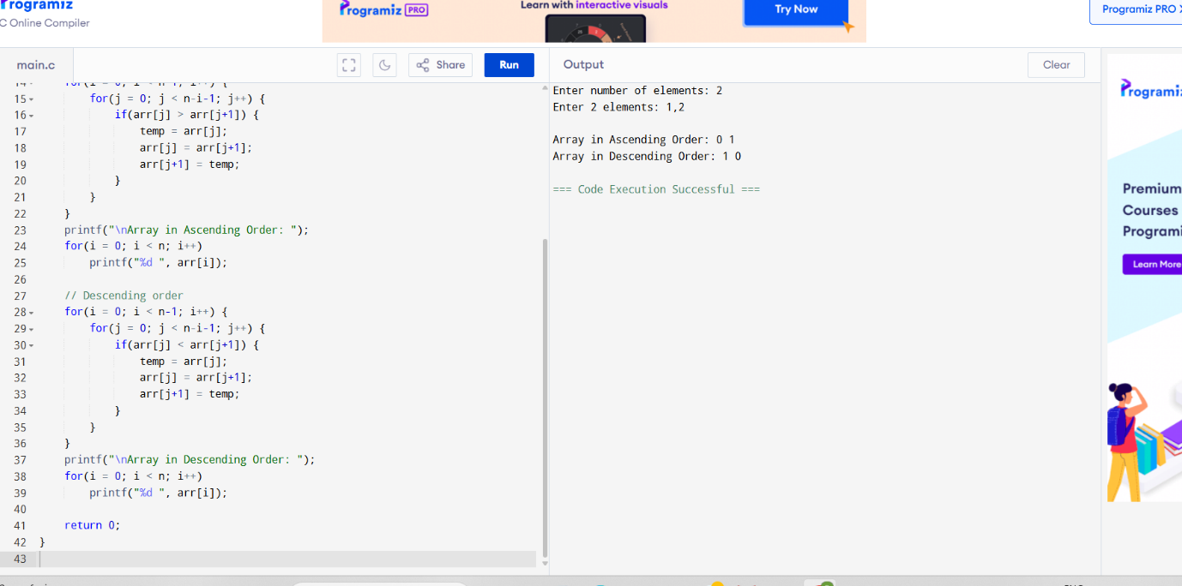

**Output**

Array in Ascending Order: 9 12 23 30 45

Array in Descending Order: 45 30 23 12 9